

UNIVERSITY INSTITUTE OF COMPUTING

PROJECT REPORT

Smart Medical Store Sales
& Inventory Analysis

Program Name: BCA

Subject Name/Code: Data mining(24CAT-307)

Submitted by: Submitted to:

Name: Jhuna Kumar Name: Ankita Ma’am
UID: 24BCA10198 Designation: Assistant Professor
Section: BCA – 2 “A” Signature:-------------------

- Introduction

The Medical Store Sales Analysis Using Data Mining Techniques project focuses on analyzing medical store data to discover useful information, identify sales patterns, and improve inventory management. Medical stores handle a large number of medicines, including their purchase prices, selling prices, quantities, suppliers, and sales records. Managing this information manually can be difficult and time-consuming.
Data Mining is the process of discovering useful patterns, relationships, and knowledge from large amounts of data. In this project, Python programming is used to analyze medical store data and extract meaningful insights. Various data mining techniques, such as Association Rule Mining (Apriori Algorithm) and Clustering Analysis (K-Means Algorithm), are applied to understand medicine purchasing patterns and group medicines based on their characteristics.
The Apriori algorithm helps identify relationships between medicines that are frequently purchased together. K-Means clustering groups medicines according to similar features, such as selling price, purchase price, and quantity. These techniques can help a medical store understand customer purchasing behavior, identify popular medicines, and organize inventory more effectively.
The project also includes data preprocessing, data transformation, pattern discovery, and data visualization using Python libraries such as Pandas, NumPy, Matplotlib, and Seaborn. Graphs and charts are used to present the analysis results in a clear and understandable way.
The main purpose of this project is to demonstrate how data mining techniques can be applied to medical store data to support better decision-making, improve inventory planning, and increase business efficiency.

- Problem Statement

Medical stores manage a large amount of data related to medicines, including medicine names, purchase prices, selling prices, quantities, suppliers, and sales transactions. Managing and analyzing this data manually can be difficult, time-consuming, and prone to errors. Due to the lack of proper data analysis, medical store owners may face problems in identifying popular medicines, understanding customer purchasing behavior, and maintaining an appropriate inventory level.
Traditional methods of inventory management do not provide sufficient information about the relationships between medicines or the purchasing patterns of customers. As a result, medical stores may experience overstocking of less-demanded medicines, shortages of frequently purchased medicines, and inefficient stock management.
The main problem is how to analyze medical store data effectively and extract useful information that can support better business decisions. Therefore, this project uses data mining techniques such as the Apriori Algorithm and K-Means Clustering to discover frequent medicine combinations, group similar medicines, and identify meaningful patterns in the dataset.

- Objectives

The main objective of the Medical Store Sales Analysis Using Data Mining Techniques project is to analyze medical store data and discover useful patterns that can help improve sales analysis and inventory management.
The specific objectives of the project are:
1. To Analyze Medical Store Data: To examine medicine details, purchase prices, selling prices, quantities, and sales records.
2. To Perform Data Preprocessing: To clean the dataset by handling missing values, duplicate records, and incorrect data.
3. To Transform Data: To convert raw data into a suitable format for data mining and analysis.
4. To Identify Purchasing Patterns: To use the Apriori Algorithm to discover medicines that are frequently purchased together.
5. To Apply Clustering Techniques: To use the K-Means algorithm to group medicines based on similar characteristics, such as price and quantity.
6. To Discover Hidden Patterns: To identify useful relationships and trends in medical store data.
7. To Perform Data Visualization: To represent the analysis results using charts and graphs such as bar charts, pie charts, and scatter plots.
8. To Support Inventory Management: To identify popular medicines and help maintain suitable stock levels.
9. To Improve Decision-Making: To provide meaningful insights that can help medical store owners make better business decisions.
10. To Apply Python in Data Mining: To demonstrate the practical use of Python libraries such as Pandas, NumPy, Matplotlib, Seaborn, and Scikit-learn for data analysis.

- Scope of the Project

The scope of the Medical Store Sales Analysis Using Data Mining Techniques project is to analyze medical store data and discover meaningful patterns that can help improve sales analysis and inventory management. The project uses Python programming and data mining techniques to convert raw medical store data into useful information.
The project focuses on analyzing medicine details such as medicine name, purchase price, selling price, quantity, and sales records. Data preprocessing techniques are used to clean the dataset by handling missing values, duplicate records, and incorrect data. Data transformation is performed to prepare the data for further analysis.
The project applies the Apriori Algorithm to identify frequently purchased medicine combinations and discover relationships between different medicines. The K-Means Clustering Algorithm is used to group medicines based on similar characteristics, such as price and quantity. These techniques help identify medicine categories, purchasing patterns, and useful business insights.
The project also includes data visualization using graphs and charts such as bar charts, pie charts, scatter plots, and histograms. These visualizations make the results easier to understand and interpret.
- Tools and Technologies Used
The Smart Medical Store Sales and Inventory Analysis project is developed using various tools and technologies to analyze medical store data and discover useful patterns. These tools help in data processing, data mining, and visualization.

1. Python: Python is the main programming language used in this project. It is simple, flexible, and provides several libraries for data analysis and visualization.

2. Pandas: Pandas is used to load, organize, clean, and process the medical store dataset. It helps manage data in rows and columns and perform calculations such as total sales.

3. Matplotlib: Matplotlib is a Python library used to create graphs and charts, including bar charts, pie charts, scatter plots, and histograms.

4. Seaborn: Seaborn is used to create statistical visualizations such as box plots and correlation heatmaps. It helps represent relationships between numerical attributes.

5. Scikit-learn: Scikit-learn is used to implement the K-Means clustering algorithm. It also provides the StandardScaler tool to normalize numerical data before clustering.

6. Excel: Microsoft Excel is used to store, organize, and prepare the medical store dataset. It also supports basic calculations and data inspection.

7. WEKA: WEKA is a data mining tool that can be used to apply algorithms such as Apriori and K-Means through its graphical interface.

8. Jupyter Notebook / VS Code: These development environments are used to write, execute, and test Python code.

- Data Visualization
Data visualization is an important part of the Smart Medical Store Sales and Inventory Analysis project. It helps convert raw medical store data into graphical representations that are easy to understand and analyze. In this project, different charts are created using Python libraries such as Matplotlib and Seaborn. These charts help identify sales patterns, medicine demand, stock distribution, and relationships between different numerical values.
A bar chart is used to compare the quantity of different medicines. It helps identify which medicines have higher or lower quantities. A pie chart represents the percentage contribution of each medicine to the total quantity. It provides a clear view of how the total quantity is distributed among medicines.
A scatter plot is used to analyze the relationship between selling price and medicine quantity. It helps observe whether medicines with higher selling prices have different quantity patterns. A histogram shows the distribution of medicine quantities and helps understand how frequently different quantity ranges occur.
A box plot is used to identify the spread of medicine quantities and detect possible outliers. It helps determine whether some medicines have unusually high or low quantities compared with the other medicines.
A correlation heatmap is created using Seaborn to display the correlation between purchase price, selling price, and quantity. Different colors represent the strength and direction of relationships between these variables. A positive correlation indicates that two variables tend to increase together, while a negative correlation indicates that one tends to decrease as the other increases.
These visualizations make the analysis more effective and meaningful. They help medical store owners understand medicine demand, compare prices, identify unusual values, and make better inventory decisions. Data visualization also improves the presentation of project results by displaying important information in a simple and graphical form. Overall, it supports better understanding of medical store sales and inventory data.

- Implementation
import pandas as pd
import matplotlib.pyplot as plt
# Create sample medical store data
data = {
"Medicine Name": [
"Paracetamol",
"Amoxicillin",
"Cetirizine",
"Ibuprofen",
"Azithromycin"
],
"Selling Price": [20, 80, 30, 50, 100],
"Quantity": [150, 90, 120, 100, 70]
}
df = pd.DataFrame(data)
# Calculate total sales
df["Total Sales"] = df["Selling Price"] * df["Quantity"]
print("Medical Store Dataset:")
print(df)
print("\nTotal Sales:", df["Total Sales"].sum())
# 1. Bar Chart
plt.figure(figsize=(8, 5))
plt.bar(df["Medicine Name"], df["Quantity"])
plt.title("Medicine Quantity - Bar Chart")
plt.xlabel("Medicine Name")
plt.ylabel("Quantity")
plt.xticks(rotation=45)
plt.tight_layout()
plt.show()
# 2. Horizontal Bar Chart
plt.figure(figsize=(8, 5))
plt.barh(df["Medicine Name"], df["Quantity"])
plt.title("Medicine Quantity - Horizontal Bar Chart")
plt.xlabel("Quantity")
plt.ylabel("Medicine Name")
plt.tight_layout()
plt.show()
# 3. Pie Chart
plt.figure(figsize=(7, 7))
plt.pie(
df["Quantity"],
labels=df["Medicine Name"],
autopct="%1.1f%%",
startangle=90
)
plt.title("Medicine Quantity - Pie Chart")
plt.axis("equal")
plt.show()
# 4. Line Chart
plt.figure(figsize=(8, 5))
plt.plot(
df["Medicine Name"],
df["Total Sales"],
marker="o"
)
plt.title("Medicine Sales - Line Chart")
plt.xlabel("Medicine Name")
plt.ylabel("Total Sales")
plt.xticks(rotation=45)
plt.tight_layout()
plt.show()
# 5. Scatter Plot
plt.figure(figsize=(8, 5))
plt.scatter(df["Selling Price"], df["Quantity"])
plt.title("Selling Price vs Quantity - Scatter Plot")
plt.xlabel("Selling Price")
plt.ylabel("Quantity")
plt.tight_layout()
plt.show()
# 6. Histogram
plt.figure(figsize=(8, 5))
plt.hist(df["Quantity"], bins=5)
plt.title("Medicine Quantity - Histogram")
plt.xlabel("Quantity")
plt.ylabel("Frequency")
plt.tight_layout()
plt.show()
# 7. Box Plot
plt.figure(figsize=(8, 5))
plt.boxplot(df["Quantity"])
plt.title("Medicine Quantity - Box Plot")
plt.ylabel("Quantity")
plt.show()
# 8. Area Chart
plt.figure(figsize=(8, 5))
plt.fill_between(
range(len(df)),
df["Total Sales"],
alpha=0.5
)
plt.plot(df["Total Sales"], marker="o")
plt.title("Medicine Sales - Area Chart")
plt.xlabel("Medicine Index")
plt.ylabel("Total Sales")
plt.tight_layout()
plt.show()

- Results and Findings

The Smart Medical Store Sales & Inventory Analysis project demonstrates the application of data mining techniques to medical store data using WEKA and Microsoft Excel.
The dataset is analyzed through data preprocessing, data transformation, association rule mining, clustering analysis, pattern discovery, and data visualization.
The Apriori Algorithm is used to identify frequently purchased medicine combinations. It helps discover relationships between medicines and provides useful information about customer purchasing behavior.
K-Means clustering groups medicines based on their purchase price, selling price, and quantity. The clustering results help identify medicines with similar characteristics.

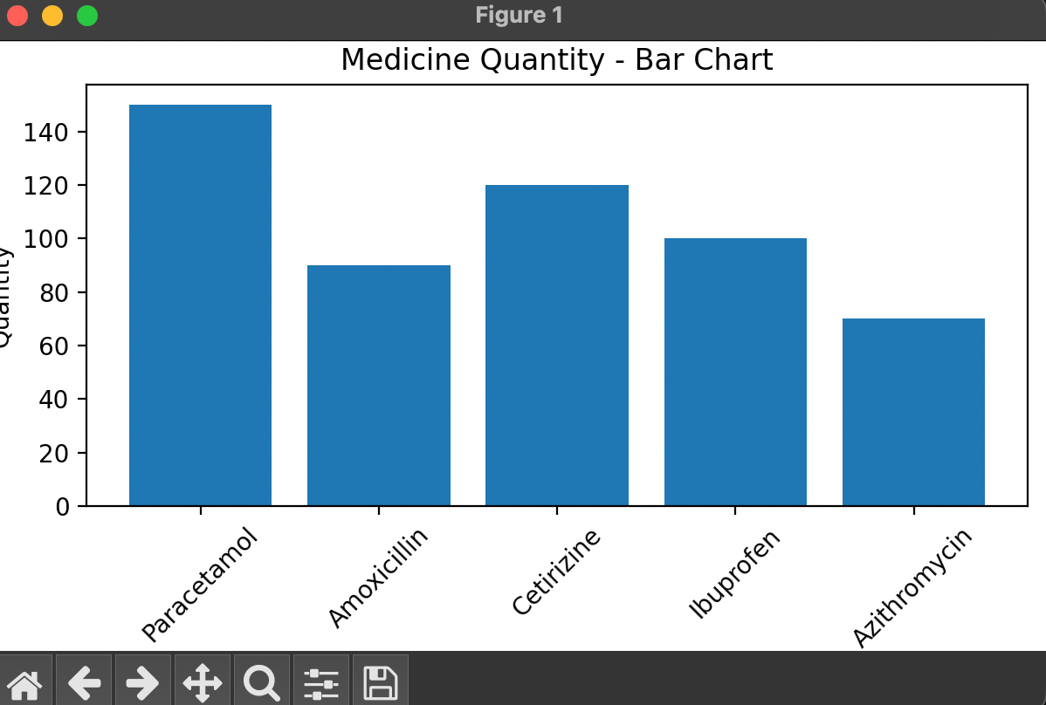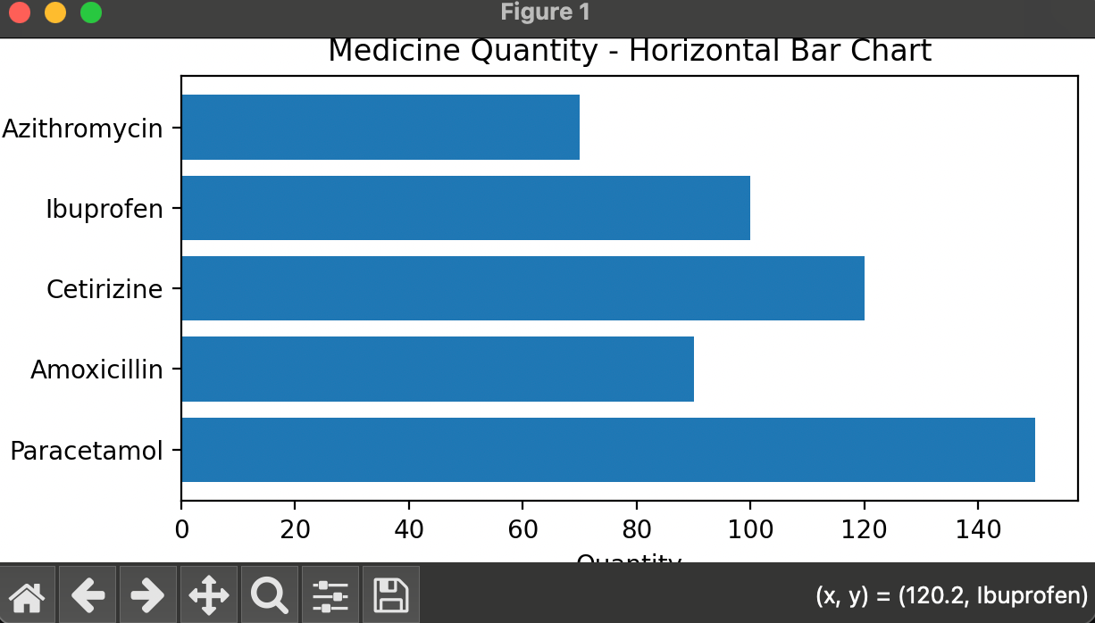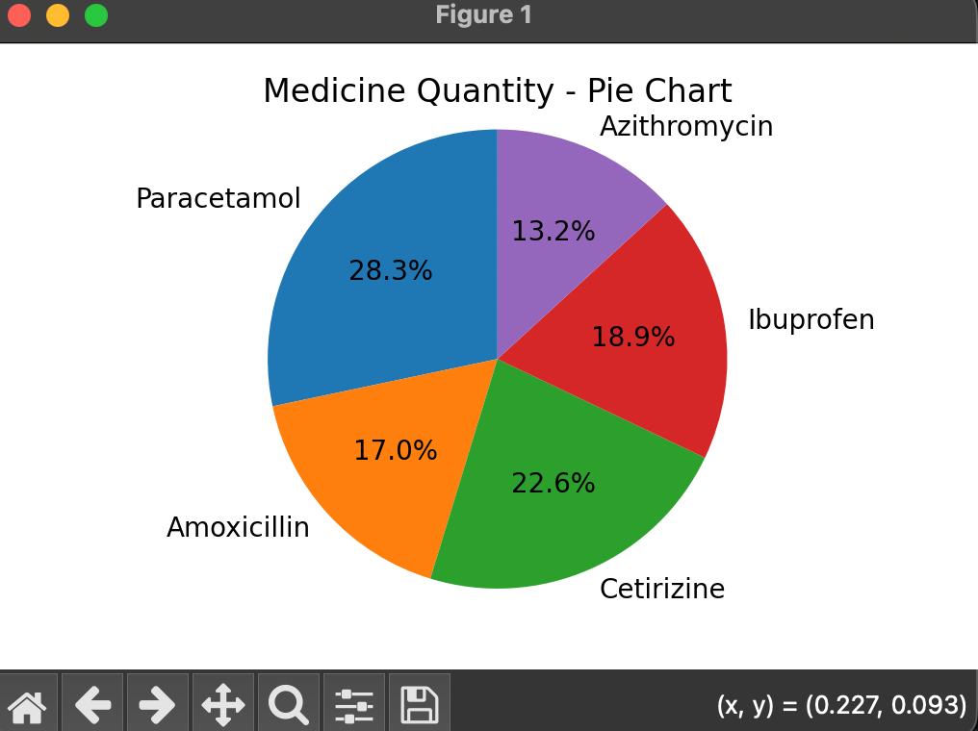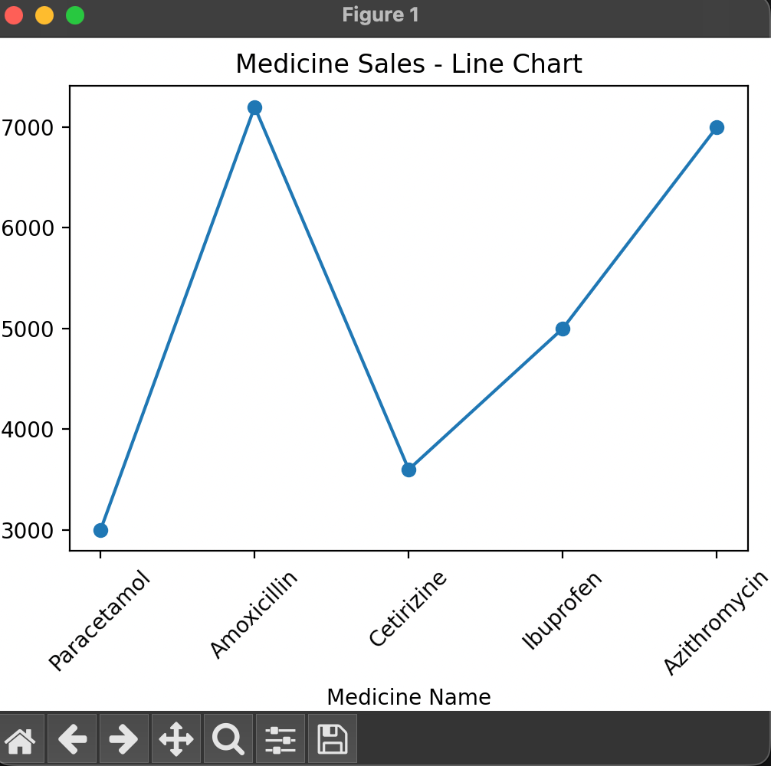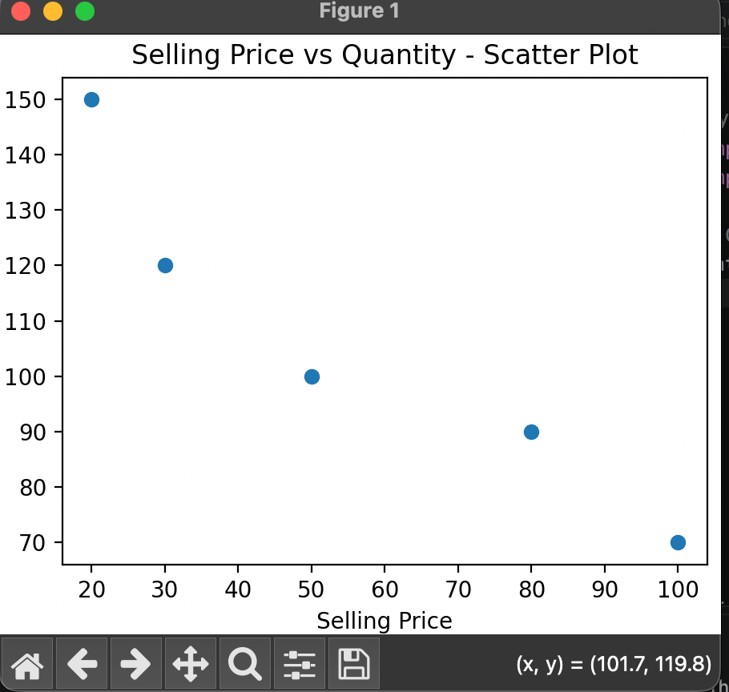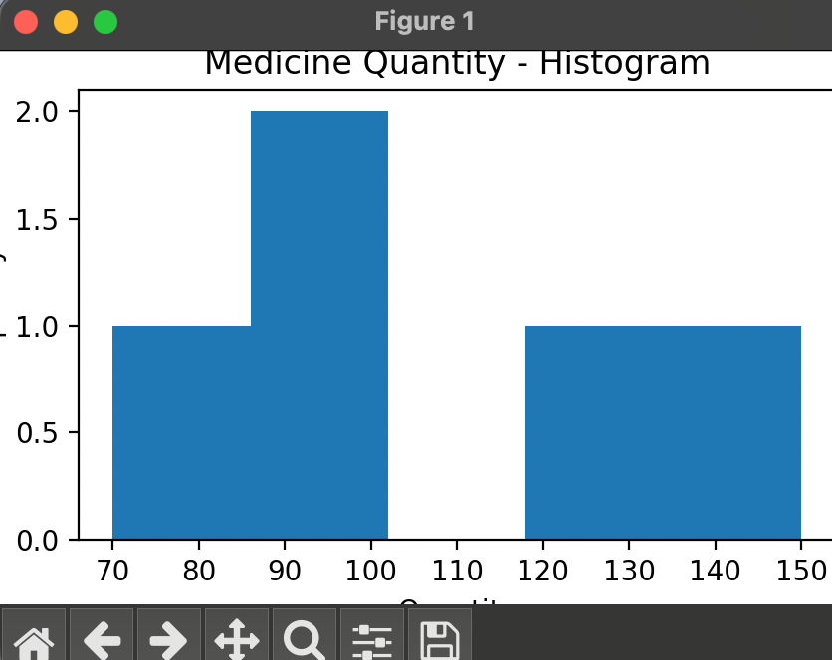

- Future Scope

The Smart Medical Store Sales and Inventory Analysis project has several possibilities for future development. The current project uses Excel and WEKA to analyze medical store data and discover useful patterns. In the future, it can be improved by adding advanced features and using modern technologies.
The project can be developed into a complete Medical Store Management System that manages medicine details, sales, purchases, suppliers, and inventory records. A user-friendly graphical interface can be created to make the system easier to operate.
Machine learning techniques can be applied to predict future medicine demand based on previous sales records. This will help medical store owners maintain the correct stock level and avoid overstocking or shortages. The system can also include an automatic expiry-date alert to identify medicines that are close to expiration.
In the future, the project can be connected to a database such as MySQL to store large amounts of medical store data securely. A web-based application can also be developed so that users can access the system from different devices.
Advanced data mining algorithms can be used to discover more useful patterns in medicine sales. For example, association rule mining can identify medicines that are frequently purchased together. Clustering techniques can group medicines based on price, quantity, and sales behavior.
Power BI or interactive dashboards can be integrated to provide real-time reports and visualizations. The system can also generate automatic notifications when medicine stock becomes low.

- Conclusion

The Smart Medical Store Sales & Inventory Analysis Using WEKA and Excel project demonstrates how data mining techniques can be used to analyze medical store data and discover useful information.
The project includes important steps such as data preprocessing, data transformation, association rule mining, clustering analysis, pattern discovery, and data visualization.
The Apriori Algorithm helps identify frequently purchased medicine combinations and discover relationships between different medicines. K-Means clustering groups medicines based on similar characteristics, such as purchase price, selling price, and quantity.
Microsoft Excel is used for data management, calculations, and visualization, while WEKA is used to apply data mining algorithms. The results are presented through charts and tables to make the analysis easier to understand.
The project provides practical knowledge of data mining techniques and their application in the medical store business. It also demonstrates how WEKA and Excel can be used together for data analysis and decision-making.

- References



